Home Learning Reception Suggested Daily Timetable

09:00 – 09:30 - Phonics - using the letters and sounds YouTube videos.
09:30 – 11:00 – Choosing time and snack – Please choose an activity from the activity pack provided.
11:00- 11:30 - Maths
12:00-12:30 – Lunch
12:30 – 14:00 – Small group work /reading and letter formation – Children will be invited on teams to small group sessions. Whilst waiting for your child’s team meeting this is a great opportunity to read with your child and practise their letter formation.
14:00-14:30 - English
14:30-14:45 – Story time – enjoy a story with your child.

Monday
Phonics – New sound – X https://www.youtube.com/watch?v=Q0NhvOaLbY4
Reading - https://www.youtube.com/watch?v=3T6Y5kgSKxY
Maths
Who Sank the boat
Learning Objectives:
- To compare weights.
- To introduce the vocabulary “heavy”, “heavier”, “heaviest”, “light” , “lighter” and “lightest”.
- To use full comparative sentences. For example “this is the heaviest and this is the lightest.”

Watch “Who Sank the Boat?” ( https://www.youtube.com/watch?v=ZpFWuHSDFtQ )

Pause the video at 27 seconds when you will hear the words “do you know who sank the boat?”
*You will watch the rest of the video in tomorrow’s maths lesson.

Discuss with your child which animal they think will sink the boat.
- Why do you think this animal will sink the boat?
- Could it be any other animal?

Guidance for parents – try to encourage your child to use words related to weight such as heavy and light. Remember your child is likely to use the words “not heavy.” Reflect back the word light and use comparative statements, for example “the cow is heavy and the mouse is light.”

Introduce the words “heavy”, “heavier”, “heaviest”, “light” , “lighter” and “lightest” so your child can begin to compare weight.

Practise using these words to compare the weight of three household objects. For example a two litre bottle of water, a tin of beans and a potato.

English
Dear Zoo
Learning Objectives:
- To listen to the story and to begin joining in with the words and the actions.
Dear Zoo is a story that will be told as part of our Talk for Write unit. This will consist of a sequence of lessons built up over a number of weeks. The children will first become familiar with the story and actions before they will be expected to write their own story maps and finally their own story sentences.

Watch Miss Jones telling the story ‘Dear Zoo’ . Your child can watch this video each day until they get familiar with the story.
Once you and your child become confident, try telling it without the aid of the video as often as you can. You may want to write down the order of the animals for your reference.
Tuesday
Phonics – New sound – REVIEW https://www.youtube.com/watch?v=OQ1AnMCGTzg
Reading - https://www.youtube.com/watch?v=N2PZ_RO9pYs
Maths
Who Sank the boat
Learning Objectives:
- To compare weights.
- To introduce the vocabulary “heavy”, “heavier”, “heaviest”, “light” , “lighter”, “lightest” and “balance”.
- To use full comparative sentences. For example “this is the heaviest and this is the lightest.”

Watch “Who Sank the Boat?” ( https://www.youtube.com/watch?v=ZpFWuHSDFtQ )

Watch the whole of “Who sank the boat?”

Discuss with your child the following:
- Did you guess correctly?
- Were you surprised by who sank the boat?
- How did the lightest animal of all sink the boat?

Go back and re-read the story pausing to look closely at the details in the pictures particularly at what happens to the boat as each animal gets in. Notice the boat gets lower in the water as each animal gets in. You will notice at the very end of the story the boat is so low that the boat is nearly level with the water and the animals are almost getting wet.

Get a plastic container (something that floats). Select some small objects e.g. coins, Lego or small balls of playdough. Place your empty container in a bowl of water e.g. washing up bowl. Begin carefully placing your small objects in to the boat one by one. Notice what happens. What could you do if your boat begins to tilt? (This is a good opportunity to introduce the word balance.)
English
Dear Zoo
Learning Objectives:
- To listen to the story and to begin joining in with the words and the actions.
- To use information books and the internet to find out facts about zoo animals.

Watch Miss Jones telling the story ‘Dear Zoo’ . Your child can watch this video each day until they get familiar with the story.

Choose a zoo animal that you would like to know more information about. Can you find out more about it using the internet or some information books?
Get Epic is a fantastic website that allows you access to lots of fiction and non-fiction books. You can sign up for free for 30 days. https://www.getepic.com/ Some books we suggest are:

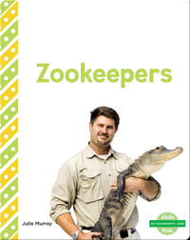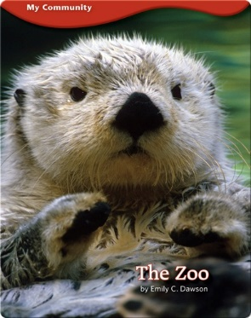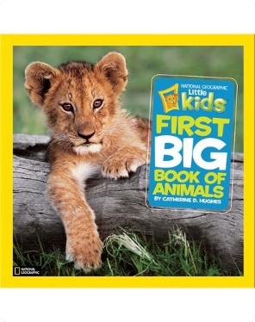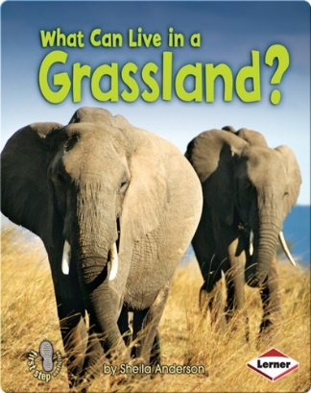

- Explore the books in more detail. Are these different from story books? Why? Highlight your child to features such as a contents page and explain that we don’t have to read an information book from the beginning. Model looking for the correct page number, showing your child that each page has a number on it that can help us find the correct page quickly. Look out for real photographs in information books.
- If using the internet, model how you can search for anything you like by typing the name into the search box. Ask your child to help you with sounding out the words.

Wednesday
Phonics – New sound – y https://www.youtube.com/watch?v=jFR1LoM6Giw
Reading - https://www.youtube.com/watch?v=SZ4YqxbBybo
Maths
Who sank the boat?
Learning Objective:
- To represent numbers in different ways
- To use the word balance in a sentence
Repeat yesterday’s activity of exploring how to balance a boat. You can remind your child of what they have learnt and explore different materials to make your boat and different objects. You may want to vary the weight of the objects. Help your child to record the number of objects they can put in to the boat before it sinks. They can either record this by representing marks one by one or record the total. Here are some examples:

- If representing numbers using a tally please avoid using use of the five bar gate at this stage. It is easier for the children to tally one by one.

(five bar gate)

Challenge: Help your child to compare the total number of objects in each boat. Which boat was the most successful?
English
Dear Zoo
Learning Objectives:
- To listen to the story and to begin joining in with the words and the actions.
- To hear the dominant sounds in words.
Watch Miss Jones telling the story ‘Dear Zoo’ . Your child can watch this video each day until they get familiar with the story.

Make a poster or little information booklet of a zoo animal using some of the information you found out yesterday. Encourage your child to draw the animal and model writing some words. Ask your child to help you to sound out the words they can hear. You can do a joint write with your child as modelling the writing process is just as important as them doing the writing.
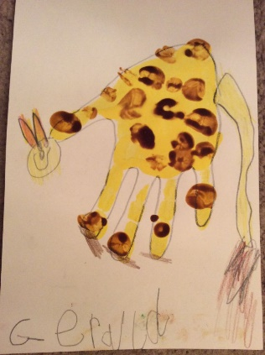
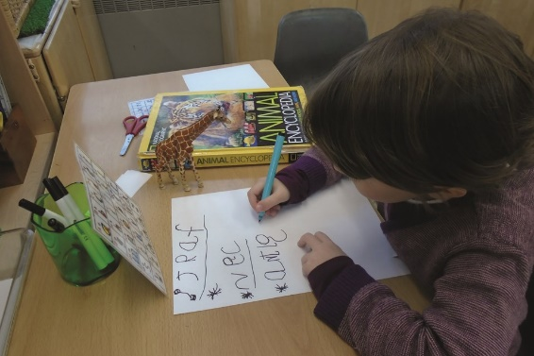

Thursday
Phonics – New sound – z https://www.youtube.com/watch?v=mTpbxjasiQI
Reading - https://www.youtube.com/watch?v=N2Gz0avTavc
Maths-
Doubles
Learning Objective:
- To recognise doubles and their totals.

Please listen to the doubles rhyme you’re your child. https://www.educreations.com/lesson/view/doubles-rhyme/54182833/?s=k9GPSh&ref=appemail

Play the maths game double double here comes trouble.

Have 2 dice and take it in turns to roll both dice. When a double is rolled, the children have to quickly stand up and turn around shouting ‘double double here comes trouble’ and sit back down again.

Remember to sing the rhyme when a double is rolled e.g. “Three flies met three flies picking up sticks. Three flies met three flies together makes six.”

*If you do not have a dice then you can make a spinner or use a virtual dice online. Dotted dice is easier for children to see the patterns of the doubles.
English
Field Trip to Edinburgh Zoo
Learning Objectives:
- To see some animals in their natural habitats
- To find out some more facts about zoo animals

You and your child are going to go on a virtual field trip to Edinburgh Zoo. Before you go, you should make a pair of binoculars so you can see better.
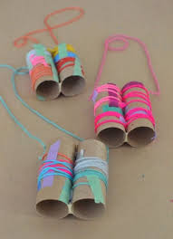
Now you are ready for your trip. Here is the website: https://www.edinburghzoo.org.uk/webcams/panda-cam/
What animals can you find? What are they up to? Sometimes you may see the Zookeepers feeding the animals. Talk to your child about ‘habitats’.
Friday
Phonics – New sound – zz https://www.youtube.com/watch?v=TPQhwBfKC-g
Reading - https://www.youtube.com/watch?v=Kr75ZFy81aA
Maths-
What’s the temperature?
Learning Objective:
- To understand that zero is not always the first number on a number line
- To understand the value of zero when talking about temperature
- To order numbers 0-10

As the weather has recently been below freezing, this is a good opportunity to discuss the temperature with your child.
The children are often used to seeing a horizontal number line but they also need to begin seeing numbers on a vertical number line. Make your own number cards from 0-10 by writing each digit on a separate piece of paper. Ask your child to try and order the numbers. They will probably order them in a horizontal line. Show them that they can also make a vertical number line. Explain to your child that there are numbers below the zero. For example, a temperature gauge for checking how warm or cold it is outside will have numbers below zero. Now write the numbers -1, -2, and -3 on separate pieces of paper and place them below the zero on the number line. Each day, look up the temperature on your phone or the internet and record what the temperature is on your vertical number line. You may want to look at temperatures in other countries that perhaps they have visited or other parts of the country where you may have friends or family. Try and guess the temperature each day to get a feel for what number of degrees it is. Do this over the next week.

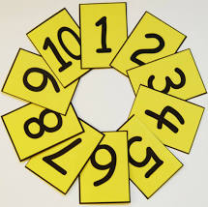
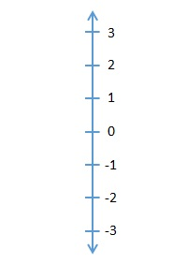
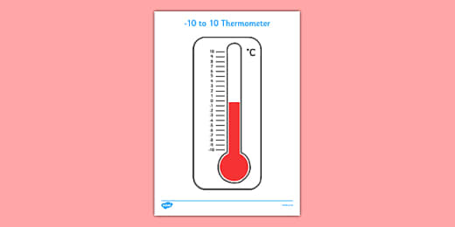

English -
Silly Soup
Learning Objective:
- To hear rhyme in words
- To play with rhyme in words

Watch Miss Blake getting her objects ready for her rhyming soup here: https://www.youtube.com/watch?v=92hzsuBBsqE
Watch the video of Miss Blake making her rhyming soup here:
https://www.youtube.com/watch?v=TASwT7-4pS4

Have a go at making your own Silly Soup. You may want to do a rhyming soup or you might want to do a sound soup, for example, all ‘s’ objects, ‘sssssssock’, ‘ssssssssscissors’, ‘sssssssnake’ etc.

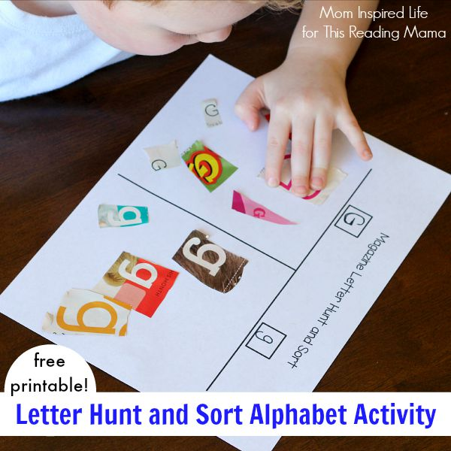
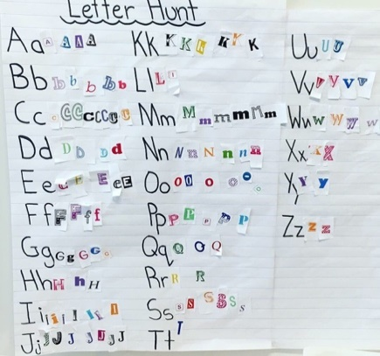
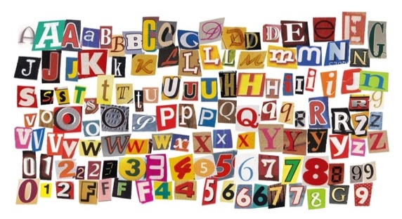
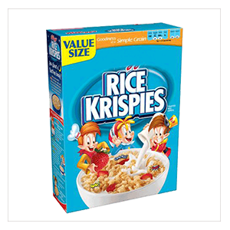
Resources

- Old magazines or newspapers
- Scissors
- Glue
- Plain paper
Method
- Find some old newspapers or magazines.
- Can you find the letters from your name and cut them out?
- Now stick them on paper to spell out your name.
- Can you try this with other people’s names that you might know?
- You might also like to use some of the pictures from the magazines to make a story.
- Listen an alphabet song here
- You could also see if you could collect all the letters from the alphabet and stick them in order.

How to get your child thinking

This activity is aimed at supporting letter recognition and alphabet practice, as well as an opportunity to use scissors to develop fine motor skills.
- Write your child’s name down and look at the shapes of the letters. What is the first letter in your name? Shall we see if we can find that in some magazines or some print around the house? Practise making the sound with your child (when your child learns phonics they will first learn the sound the letter makes before the name of the letter. You can look here to see how they are pronounced).
- What other objects begin with the first sound in your name?
- You can also encourage your child to look for print around everyday household objects such as food packaging.
- Next time you go out, have a look at the letters you can see on street signs, supermarket signs etc.

Home Learning Reception
Activity 1
Cutting Letters from Magazines

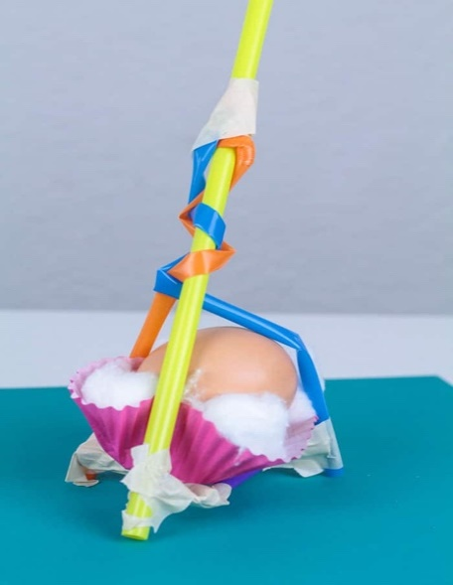
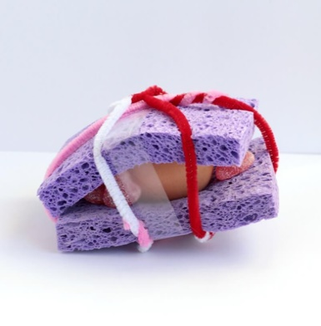
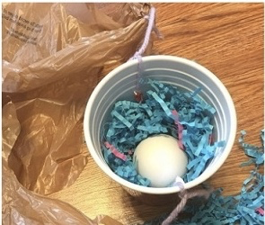
Resources
- Raw Eggs (if your child is allergic to eggs use chocolate eggs or another fragile object instead)
- Bubble wrap
- Cotton wool balls
- Silicone cup cake cases
- Cleaning sponges
- Plastic food containers
- Paper cups
- String
- Tape
- Straws

Method
The aim of this challenge is to create a container that will safely carry a raw egg onto the ground when it is dropped from something high.
- Place a selection of the above materials on a table
- Show your child a raw egg, discuss what they think would happen if you dropped it on the ground.
- Challenge them to save the egg by creating a way to protect it from the cold, hard ground!
- Encourage your child to build their egg protector and then test it
- Discuss how well their egg protector worked. Are there any ways they could improve their design to make it better?

How to get your child thinking

- What happens if you drop a raw egg on the ground?
- How are they going to protect the egg?
- What materials will they use and why?
- Why did your design work well?
- Why didn’t your design work?
- How would you change your design next time?

Home Learning Reception
Activity 2
Egg Drop Challenge

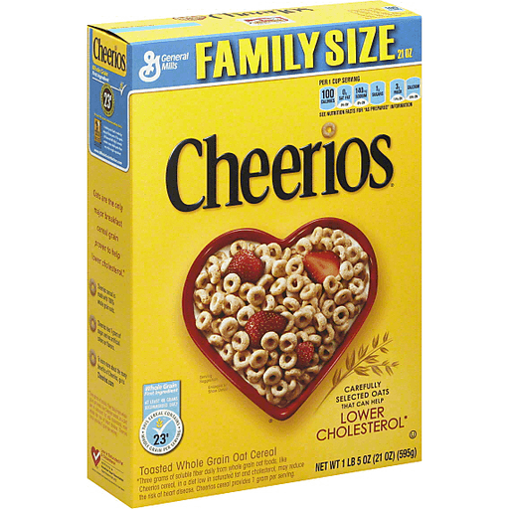
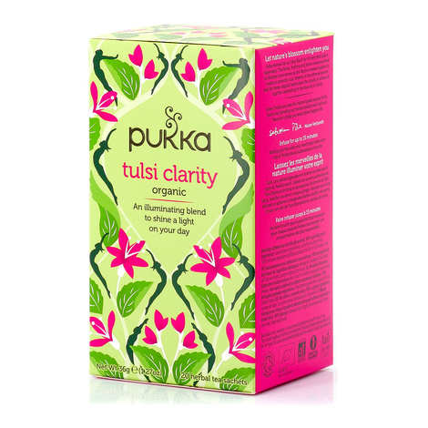
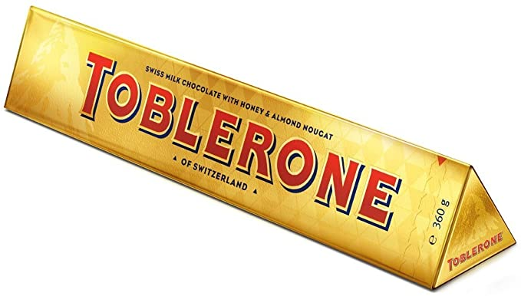
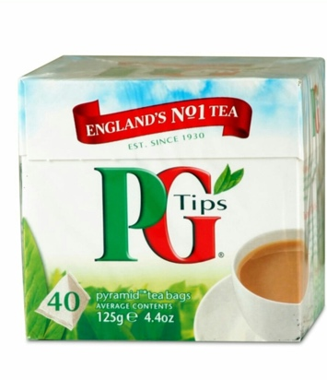
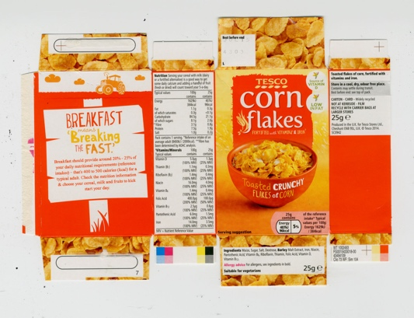
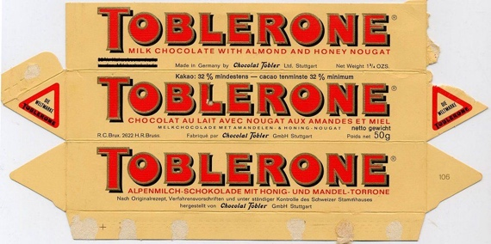
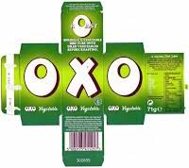
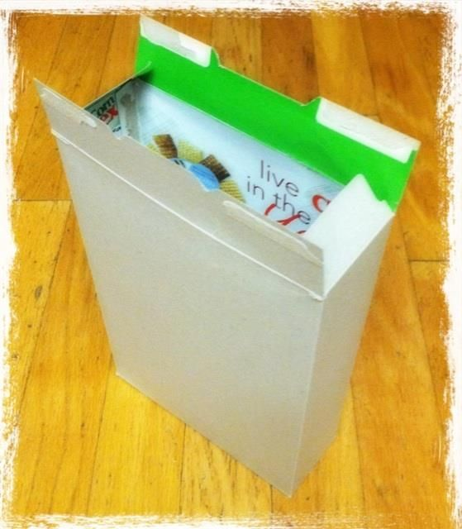
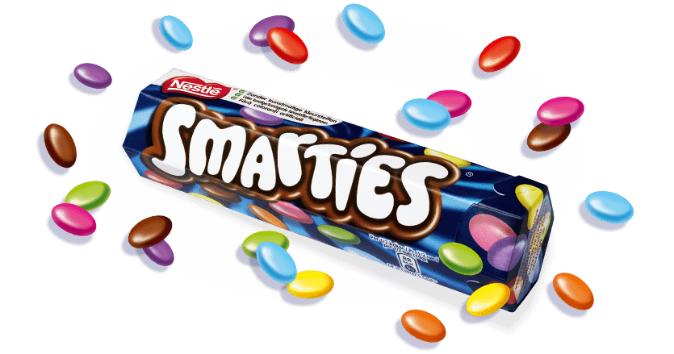
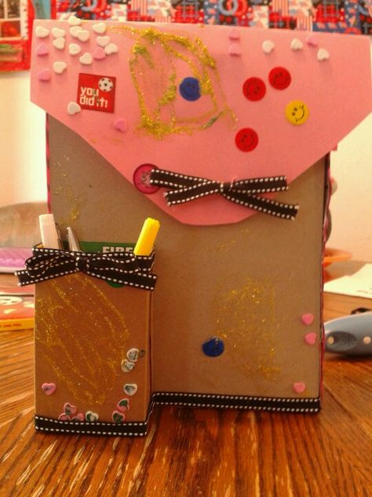
Resources
- A range of different cardboard boxes (e.g. cereal boxes, tea boxes etc.)
- Scissors
- Tape
- Coloured pens or paint.

Method
- Find a range of empty cardboard boxes at home (you may have to empty the contents of some boxes into another container if you don’t have any spare).
- Have a look at what you have found. Talk about the properties of the shapes you have found. Can you see any corners? Edges? Perhaps you can name some shapes you can see. Does your shape slide, stack or roll? Click HERE to watch a video.
- Ask an adult to find the seam part of the box and to gently open it out so it becomes unstuck. Now you can open up the box completely.
- What has happened to your 3D shape? What shapes can you now see? How many shapes can you see?
- Can you turn the 2D shapes back into 3D shapes but turn them inside out so the outside is plain?
- Now you are ready to paint, colour, decorate your boxes to construct with.

How to get your child thinking
- Can you name the 3D and 2D shapes?
- When you have made the 3D shape flat, what do you notice about the shapes? Are they the same or are some different?
- Can you explain the difference between a 2D shape and a 3D shape?
- Perhaps you can go on a shape hunt around the house to see what other shapes you can find. How could you record this? Did you find more 3D or 2D shapes? Why do you think this is?

Home Learning Reception
Activity 3
3D to 2D and back again

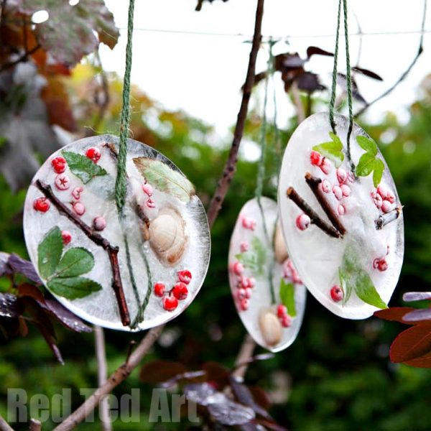
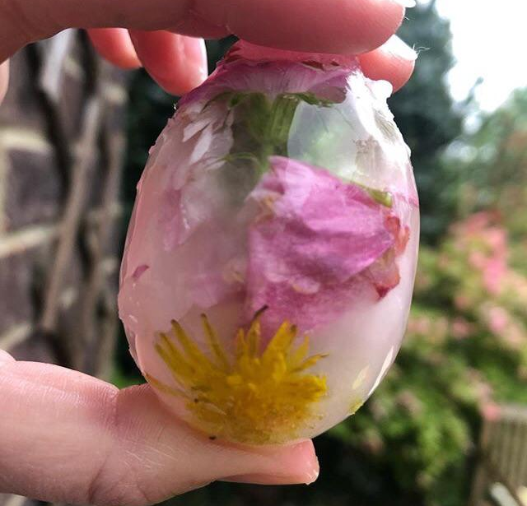

Resources
- Egg (or other small container such as a yoghurt pot).
- Natural materials found outdoors
- Water
- Freezer

Activity
- Look for some natural materials in your garden or in the park
- Carefully break off the top of a raw egg and empty the shell of its yolk and egg white
- Put in the natural materials you have found without cracking the shell
- Add water
- Put it in the freezer
- Alternatively, use a small container that can be put into the freezer. You can always add in some string that will work as a handle once your ice art freezes.
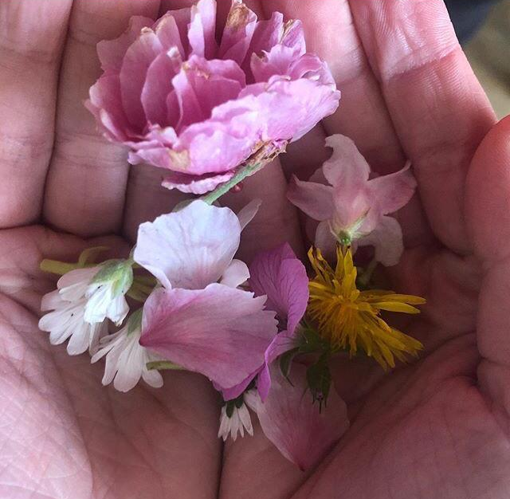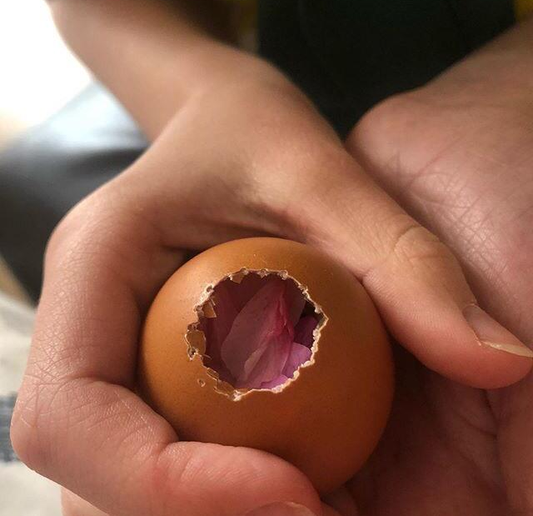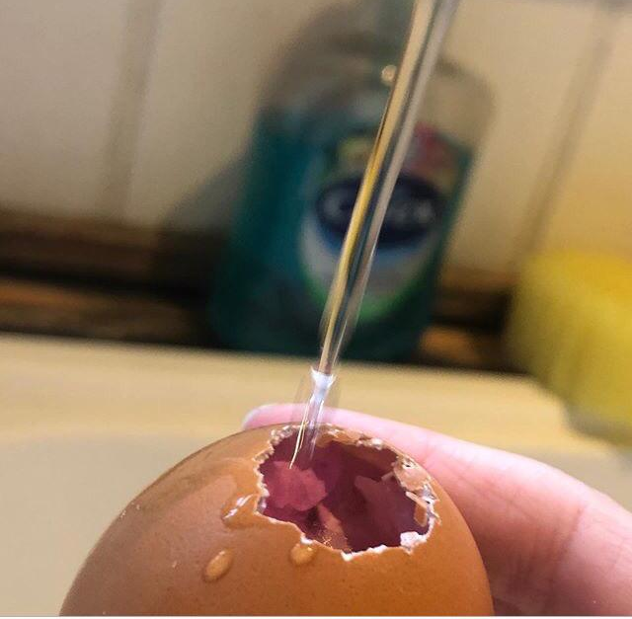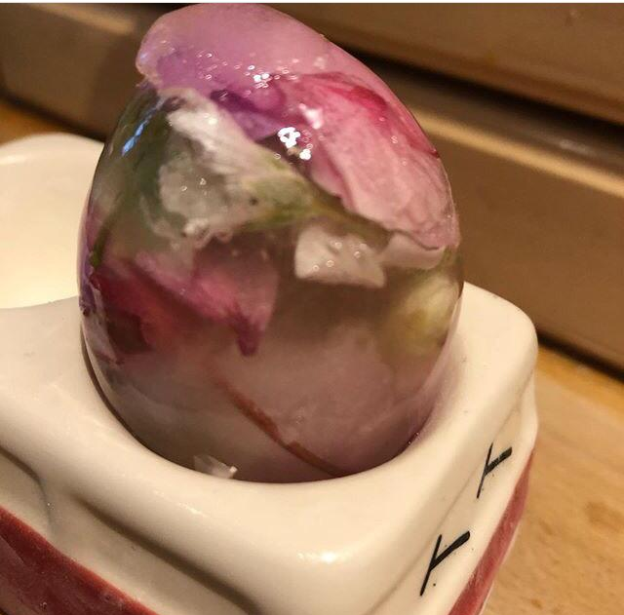

How to get your child thinking

- How long will it take for the water to freeze? Hours? Days?
- What else could we put in the egg shell?
- How long will it take for the frozen egg to melt?
- Where in your house will it melt quickest?
- How can you measure the time it might take?
- What does it feel like to hold your ‘Ice Prettiness’?

Will
Day 2 Home Learning Reception Activity 4
Egg Prettiness

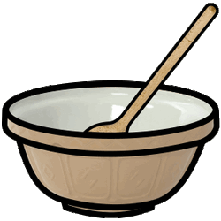
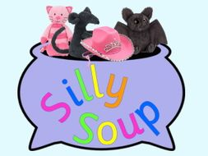
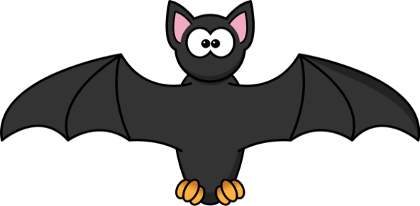
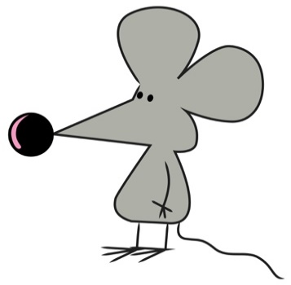
Resources
- A mixing bowl
- A wooden spoon
- Household objects
- Your singing voice
- Pieces of card cut into squares that are big enough to allow for a small drawing.
- pens and pencils.

Method
- Find pairs of objects around you house that rhyme with each other. You may, for example, have a toy cat and a hat or a dog and a log, a shoe and some goo (perhaps playdough would make good goo!) You may find that you can’t find any rhyming objects. In this case, you can start with something you do have e.g. a ‘hat’ and draw some objects that rhyme with ‘hat’. Tip: try and keep the objects 3 letter words.
- Once you have found your rhyming objects, show your child how you can use letters to write the name of the object.
- Pick your favouite pair of rhyming objects. Can you draw some more objects that rhyme with this pair? Draw one object on each piece of card. You have now made a rhyming string and are ready to make your Silly Soup.
- As you mix your soup, sing this song, adding in each item at a time: ‘I’m making silly soup I’m making soup that’s silly, I’m going to put it in the fridge to make it nice and chilly. In goes a hat, a cat, a mat, a bat, and …something fat’. (The children are familiar with the song but it goes to the tune of ‘Pop Goes the Weasel’).

How to get your child thinking
- What do you notice about the labels you have written on the rhyming objects?
- Are there any letters that are the same? Where are these letters in the word? Are they at the beginning or middle and end?
- You may notice that words can still rhyme, even though they don’t have the same letters in them e.g. whale and snail. The letters may look different but the sounds they make are the same.
- You can also add in nonsense words too, as long as they rhyme, it doesn’t matter. You can write the nonsense words on your pieces of card.

hat
bat
rat
Please see Miss Blake finding all the rhyming objects around her house HERE. You can watch the silly soup rhyme HERE.

Home Learning
Reception
Activity 5
Rhyming Silly Soup

