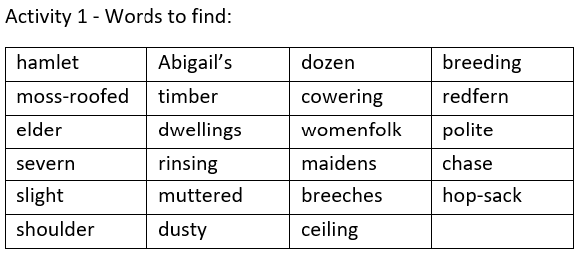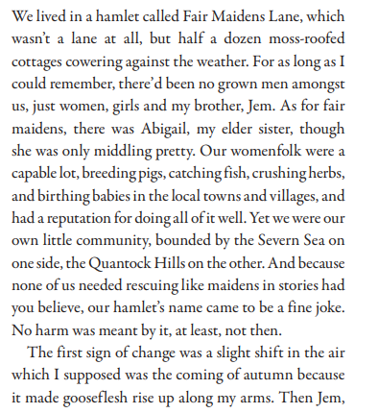

Activity 2 – Answer the questions

1. What was the first sign of change? (1mark)
2. What two places borders Fair Maidens Lane? (2marks)
3. How old is Jem? (1mark)
4. What is a synonym for capable? (1mark)
5. Explain this phrase in your own words: ‘Mercy, brother! Grow any taller and the birds’ll start perching on you.’ (2marks)
6. What do you think Old Margaret means when she says, “About time you earned your keep, and all”? (2 mark)
7. In your opinion, using PEE, what do you think it would be like to live in Fair Maidens Lane? (3marks)

